|  |  |
| --- | --- |
| **To:** Professor Darish | **Date:** November 12, 2014 |
| **From:** Trever Wagenhals | **Course & Section Number:** |
| **Subject:** Kirchhoff’s Laws and Conservation of Power Revised | **Partner(s):**  **TA:** Kyle |

**SUMMARY:**

The first section of this experiment used Kirchhoff’s Voltage Law to calculate the voltage drop at several resistors in a series circuit given 15V, then measured the voltages in an actual circuit to see how close the values were. Section 2 then involved Kirchhoff’s Current Law, where 3 resistors were in the circuit and two of the three were set in parallel. From here, calculations of the initial current and 4 different currents through the system were made, and these calculations would be compared to actual circuit measurements. Section 3 involved Power calculations, where a 4.7k Ohm resistor was placed in series with a decade box and current, power, and voltage drop of each resistor were calculated and then measured in the circuit. Section 4 had a very similar process to section 3, except instead of a decade box, there were 2 resistors, 470 Ohms and 820 Ohms, in parallel, and the current, power, and voltage drops of each resistor were to be calculated once again.

**EXPERIMENTAL APPROACH**

**Equipment and Materials**

* Resistors
* Breadboard
* Power Supply
* Multimeter
* Test Leads
* Banana Clips
* Decade Box

**Procedure**

**Section 1: KVL (Kirchhoff Voltage Law)**

In this section, a circuit on a protoboard was created with the resistors in series. The series had a 330 Ohm, 470 Ohm, and 820 Ohm resistor. Once the series was created, 15V was supplied to the circuit, and from this point voltages could be measured across each resistor. The measured voltage across each resistor was a voltage drop at that point in relation to how much resistance percentage that resistor contained. The general formula was Vx = Vs(Rx/R1+R2…+Rx) All data calculated and measured in this section is located in **Table 3-1**. Below is **Figure 3-1** of this section’s circuit.

**Figure 3-1:** Voltage drop across three series resistors

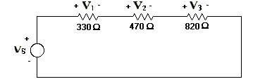

**Section 2: (Kirchhoff Current Law)**

In this section, 15V was supplied to a circuit again, except this time, 2 of the three resistors were put in parallel of each other and the current was the required data. From this circuit, there are 4 currents that must be determined. Calculations as well as actual measurements go into **Table 3-2** for comparison to see how accurate the actual application was. The general formula for solving this section was Ix = Is(I2/I2+Ix)

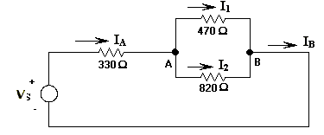

**Section 3: Power Calculation**

Section 3 involved supplying the usual 15V to a circuit, except now a decade box has been placed in the circuit. Through the decade box, numerous different resistances can be chosen to see how altering the voltages affected the rest of the circuits current and voltage drop. With the decade box in a series circuit with a 4.7k Ohm resistor, varying the resistance in the decade box caused changes in initial current and voltage drops between the two resistors. These values were calculated and measured, then recorded in **Table 3-3**. From these values, power can then be calculated at either resistor. General equations to know is I = V/R, Vx = Vs(Rx/R1+Rx), and P = VI.

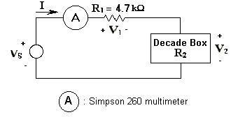

**Section 4: Conservation of Power**

Similar to **Section 3**, this section involves creating a circuit and then calculating the voltage drops and current. The differences in this section involve lowering the supplied voltage from 15V to 5V. Instead of a decade box, two resistors are used instead, 470 Ohms and 820 Ohms. In order to complete this section, the parallel resistance must be calculated to then calculate the series resistance and determine the initial current. All data for this circuit is recorded in **Table 3-4.**

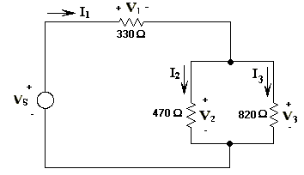

**DISCUSSION OF RESULTS**

This first Table corresponds to Section 1 of the procedure. With the three resistors in series, the equation of Vx = Vs(Rx/R1+R2…+Rx) was applied three times to calculate each resistance. When measuring, the leads were just placed on each side of the resistor. In reach calculation, the voltage added up to 15V, and the actual and theoretical were nearly identical.

**Table 3**-**1**

|  |  |  |  |  |  |
| --- | --- | --- | --- | --- | --- |
|  | V1 | V2 | V3 | Sum of Vi | VPS |
| Calculation | 3.05V | 4.35V | 7.6V | 15V | 15V |
| Measurement | 3.05V | 4.38V | 7.57V | 15V | 15V |

This table corresponds to Kirchhoff’s Current Law in Section 2 of the procedure. With three known resistors and two of them in parallel, the parallel resistance must be calculated first and then added to the series resistance to get the total resistance. Initial current can then be calculated by using I = V/R. Once initial current was determined, current is neither created nor destroyed, so it must be the initial after the first resistor. When current reaches a parallel circuit, the majority of it goes in to the path of least resistance, and the rest goes through the other. All the current must come back out of the parallel circuit to then equal the initial current again, which is shown through the calculations performed in this section. Once again, calculation and measurement were almost identical.

**Table 3-2**

|  |  |  |  |  |  |
| --- | --- | --- | --- | --- | --- |
|  | I1 | I2 | IA | IB | I1+I2 |
| Calculation | 15.16mA | 8.69mA | 23.85mA | 23.85mA | 23.85mA |
| Measurement | 15.15mA | 8.76mA | 23.85mA | 23.85mA | 23.81mA |

This Table represents all the data captured while using the Decade Box. With numerous initial resistances given to set the decade box to, different voltages drops and currents were calculated at each resistor. Through this data, it is easy to see that as the resistance in the decade box increased, the voltage dropped at the 4.7k Ohm resistor declined. With more resistance in the entire circuit, Current also decreased. Once the current and voltage drops were calculated, the power of each resistor at each resistance could be determined. It is interesting to note that the current continuously decreases, so it is to be expected that the power does the same since P = VI. All measured and calculated values fall within a tolerable percentage of error of each other.

**Table 3-3**

|  |  |  |  |  |  |  |  |  |  |  |  |  |  |  |  |
| --- | --- | --- | --- | --- | --- | --- | --- | --- | --- | --- | --- | --- | --- | --- | --- |
| R2  (kΩ) | V1 |  | V2 |  | I |  | P2 (Power in R2) |  |  |  | P1 (Power in R1) |  |  |  |  |
|  |  |  |  |  |  |  | P2=I2R2 |  | P2=V22/R 2 |  | P1=I2R1 |  | P1=V12/R1 |  |  |
|  | Cal | Mea | Cal | Mea | Cal | Mea | Cal | Mea | Cal | Mea | Cal | Mea | Cal | Mea |
| 0.5 | 13.56V | 13.54 | 1.44V | 1.46V | 2.88mA | 2.93mA | 4.14mW | 4.29mW | 4.41mW | 4.26mW | 38.99mW | 40.35mW | 38.78mW | 39.01mW |
| 2.35 | 10V | 9.94V | 5V | 5.06V | 2.13mA | 2.15mA | 10.66mW | 10.86mW | 10.63mW | 10.89mW | 21.32mW | 21.73mW | 21.28mW | 21.02mW |
| 4.7 | 7.5V | 7.44V | 7.5V | 7.57V | 1.60mA | 1.61mA | 12.03mW | 12.18mW | 11.96mW | 12.19mW | 12.03mW | 12.18mW | 11.97mW | 11.78mW |
| 6.16 | 6.49V | 6.43V | 8.51V | 8.58V | 1.40mA | 1.39mA | 12.08mW | 11.9mW | 11.76mW | 11.95mW | 9.21mW | 9.08mW | 8.96mW | 8.80mW |
| 8.6 | 5.3V | 5.24V | 9.7V | 9.76V | 1.13mA | 1.14mA | 10.98mW | 11.18mW | 10.94mW | 11.07mW | 7.94mW | 6.11mW | 5.98mW | 5.84mW |
| 9.15 | 5.1V | 5.03V | 9.9V | 9.97V | 1.08mA | 1.02mA | 10.67mW | 9.52mW | 10.71mW | 10.86mW | 5.48mW | 4.89mW | 5.28mW | 5.38mW |

Cal = calculation, Mea = measurement

This table is data that was calculated from Section 4 of the procedure. Similar to the last section, initial current and voltage dropped are necessary information to calculate. On top of that, current across each parallel resistor must be calculated on top of the initial current because this is not a series circuit. Using 5 volts as the initial voltage, and calculating the initial current by adding up the parallel and series resistors and dividing that by the voltage, the initial current is known. As explained in other portions, the current over a series resistor will always be equal to the current that entered it. Across the parallel resistors, the current is equal to the initial current that entered divided by the opposite resistor’s resistance over the total resistance in the parallel portion. This section manages to combine the tasks from Section 3 and relate them back to Section 2 to get more information out of the circuit and see the comparison.

Table 3-4

|  |  |  |  |  |  |  |  |  |  |
| --- | --- | --- | --- | --- | --- | --- | --- | --- | --- |
| I1 | I2 | I3 | V1 | V2 | V3 | PS | P1 | P2 | P3 |
| 7.91mA | 5.03mA | 2.92mA | 2.62V | 2.38V | 2.38V | 5 | 20.7mW | 11.98mW | 6.94mW |

**Section 1:**

**State the relationship between the voltage drops across series-connected resistors and the voltage applied to the entire circuit:**

Voltage drop across a resistor is equal to the initial voltage supplied times the resistance of the resistor in question, divided by the total resistance of the series circuit.

**Express your answer above as a mathematical formula.**

Vx = Vs(R1/+R1+R2+…Rn)

**Section 2:**

**For each node A and B indicate the entering currents and leaving currents.**

Because current travelling through a circuit must be equal to the total supplied current and there is only one current source, the initial current will enter A, and then it must also come out of B to follow conservation of current laws.

**Explain in your own words the relationship between the currents entering and leaving a junction point A, B in the circuit:**

All current entering a point must also come out of that point. So, because a certain amount of a current enters through A, takes two paths, and then leaves through B, the current entering B must be the same as the current leaving A.

**Write a mathematical formula for each node.**

Node A in = IA.  
Node A out = I1 + I2.  
Node B in = I1 + I2.   
Node B out = I1 + I2.   
IA = I1 + I2  
Node A in/out = IA.   
Node B in/out = IA.

**Section 3:**

**Plot P2 vs R2. Where does the peak power in R2 occur?**

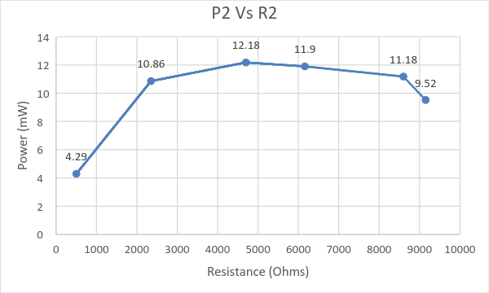

The peak power in R2 occurs when the R2 and R1 have identical resistances at 4.7k Ohms.

**What are the differences between power calculations?**

The differences between power calculations are upwards to .7mW. When the numbers are small, that may seem like a large portion, but these are also very small numbers if compared to Watts, so in order to be more precise, more precise tools would probably have to be used to get a narrower margin of error.

**Section 4.**

**Verify the KCL and KVL.**

V1 + V2 = 5 The total voltage over this loop is equal to the initial voltage

V1 + V3 = 5 The total voltage over this loop is equal to the initial voltage

I2 + I3 = I1 The current between the two parallel wires is equal to the initial current.

**What is the power delivered by the source? (Ps)**

Ps = I1(Vs) = 7.91mA(5V) = 39.55mW

**What is the power absorbed by each resistor?**

P1 = 20.7mW

P2 = 11.98mW

P3 = 6.94mW

**Is the algebraic sum of the absorbed power equal to the power delivered by the source? If so, what does that mean, If not, why not?**

The values are almost exact. Because rounding was performed, the power that each resistor needed was slightly off, causing a .07mW error. They should, in theory be exactly the same though. The same amount of power that goes in must be used because current is neither created nor destroyed. If more power than needed was to go in, it could potentially damage parts because they would be taking more Watts than needed. Even if the parts managed to survive, that is still very wasteful in terms of energy usage.